**Framework ---Work flow chart**

Framework:

In automation Testing, how to organize all automation activities and create standard Process to develop and execute automation test is called Automation Framework.

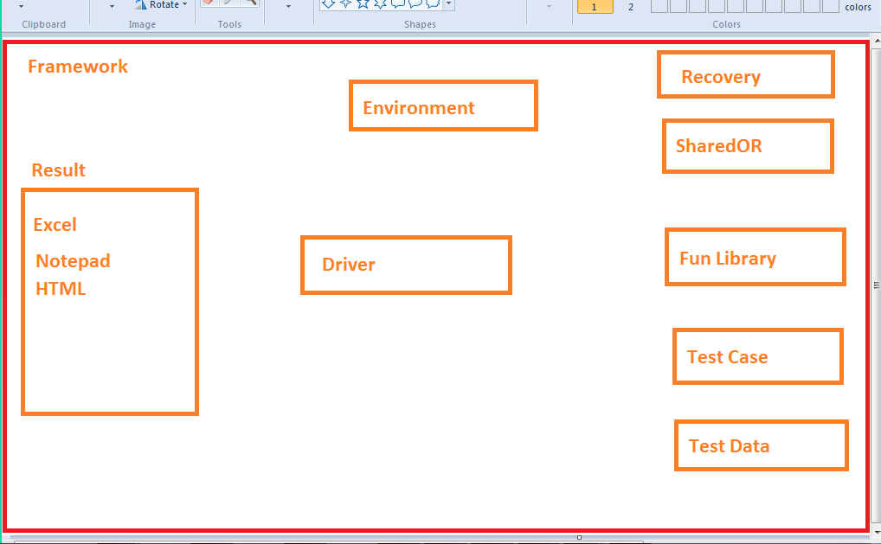

First need to create folder and get test data and test case

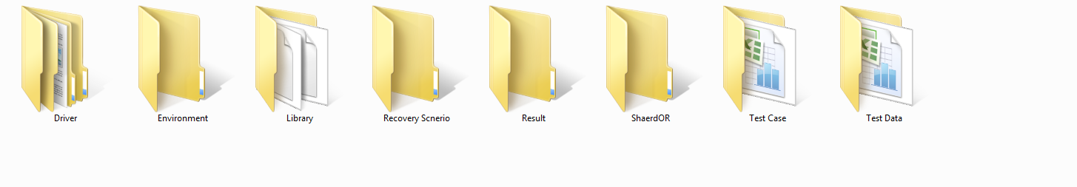**1st step (Main Script)**

1. in Action1: Get the path (use environment) from Script, split path and make folder path
2. Show all the folder (from Framework) path one by one
3. Import sheet from Test Data Applist to Datatable RunApplist

example: call importsheet(tesdatafile path,"Applist","Runapplist")

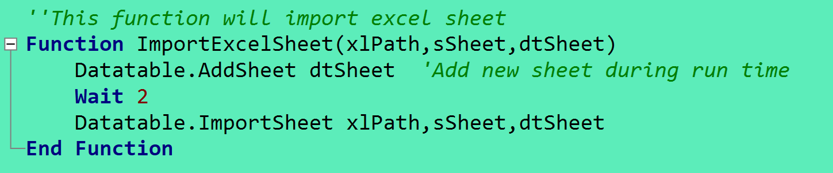

1. Then use Rowcount , use for loop to put Applist data to Datatable Runapplist

exmpl: iExecute=datatable.value("Applist","Runapplist")

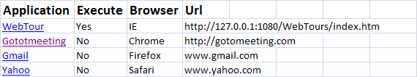

1. if execute yes then use Oneiteration to go to Apps script (like-webtour)

Example : RunAction iApplication, oneiteration

**2nd Step (in AppScript page)**

1. Declare global variable (make Environment variable) for Testdatafile, Testcasefile,bro and url
2. Import sheet from Test data app (like Webtour) to datatable Runwebtour

Example: call Importsheet(testdatafile path,"Webtour", "Runwebtour")



1. Declare variable from Test data Application (like webtour-iRole)

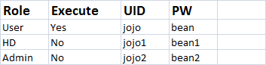

1. Use Row count, for loop to set data from Application (like webtour to runwebtour)

Example: iExecute=datatable.value("Execute","Runwebtour")

1. if Execute Yes then import sheet from Test case file to datatable

Example: Call importsheet(Testcasefile path,"User","RunUser")



1. Then need to select role from testdata app (like webtour) sheet.

Example: Select case iRole

1. if any role yes then we need to use function to execute that role.

Example: call function will be from App specific function library

**3rd steep (App specific function)**

1. Declare variable from Testcase file (like-ITCID)



14. Use row count and for loop to put data from Testcase file (Role, like- user) to datatable.

15. if any test case execute yes then call particular test case (like-W001) for execution

example - **Call** fVerifyWTlandingPage(sSheet,uid,pw,bro,url,iExp)

16. make function in the app specific script for execution